Intro:
Android is a software package which includes middleware and some key applications l,inux based operating system for mobile devices such as tablet computers and smartphones.
It is developed by Google and later the OHA (Open Handset Alliance)
- Andy Rubin(oct 2003 )
- Google(Aug 2005)
- Announcement of dev of android(2007)
- First Android in HTC(2008)

Code name | Version number | Initial release date | API level
N/A | 1.0 | September 23, 2008 | 1
N/A | 1.1 | February 9, 2009 | 2
Cupcake | 1.5 | April 27, 2009 | 3
Donut | 1.6 | September 15, 2009 | 4
Eclair | 2.0 – 2.1 | October 26, 2009 | 5 – 7
Froyo | 2.2 – 2.2.3 | May 20, 2010 | 8
Gingerbread | 2.3 – 2.3.7 | December 6, 2010 | 9 – 10
Honeycomb[a] | 3.0 – 3.2.6 | February 22, 2011 | 11 – 13
Ice Cream Sandwich | 4.0 – 4.0.4 | October 18, 2011 | 14 – 15
Jelly Bean | 4.1 – 4.3.1 | July 9, 2012 | 16 – 18
KitKat | 4.4 – 4.4.4 | October 31, 2013 | 19 – 20
Lollipop | 5.0 – 5.1.1 | November 12, 2014 | 21 – 22
Marshmallow | 6.0 – 6.0.1 | October 5, 2015 | 23
Nougat | 7.0 | August or September 2016 | 24

API Levels generally mean that as a programmer, you can communicate with the devices' built in functions and functionality. As the API level increases, functionality adds up (although some of it can get deprecated).

Android Architecture:

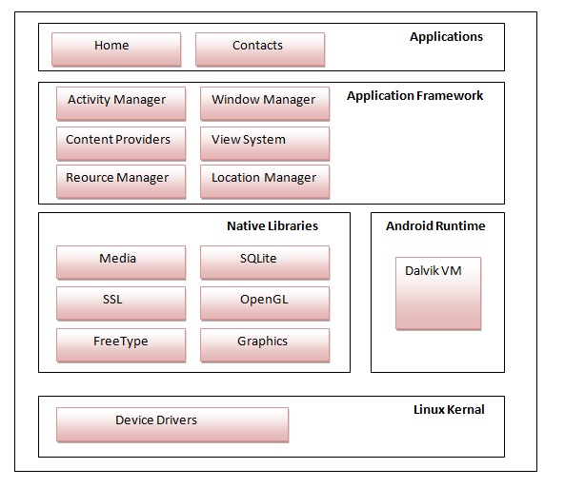
Note:
Linux kernel is responsible for device drivers, power management, memory management, device management and resource access.
Native Libraries:The WebKit library is responsible for browser support, SQLite is for database, FreeType for font support, Media for playing and recording audio and video formats.
DVM is like JVM but it is optimized for mobile devices,which is responsible to run android application,memory, battery life and performance.
Android framework includes Android API's such as UI (User Interface), telephony, resources, locations, Content Providers (data) and package managers. It provides a lot of classes and interfaces for android application development.

The core building blocks or fundamental components of android are
Activities(An activity is a class that represents a single screen),
Views(Anything that you see is a view),
Intents(Start the service ,Launch an activity ,Display a web page,Dial a phone call),
Service(is a component that runs in the background, without needing to interact with the user and it works even if application is destroyed),
Content providers(used to share data between the applications.),
fragments(Fragments are like parts of activity)
and AndroidManifest.xml(It contains informations about activities, content providers, permissions etc)

Android Virtual Device (AVD)
Bin contains apk file.
R.java is autogenerated file to give ids to all the resources of res folder.

Android WebView(xml)
webView.loadUrl(“url”);

Activity LifeCycle

Method | Description
onCreate | called when activity is first created.
onStart | called when activity is becoming visible to the user.
onResume | called when activity will start interacting with the user.
onPause | called when activity is not visible(partial) to the user.
onStop | called when activity is no longer visible to the user.
onRestart | called after your activity is stopped, prior to start.
onDestroy | called before the activity is destroyed.

When App Starts
onCreate();
onStart();
onResume();
When Home Button(activity is not visible)
onPause();
onStop(); ====>>onStart()
When pressing BackButton(another activity must restart and be be on state of interaction)
onRestart();
onStart();
onResume();
DialogueBox
onPause();===>>onResume()

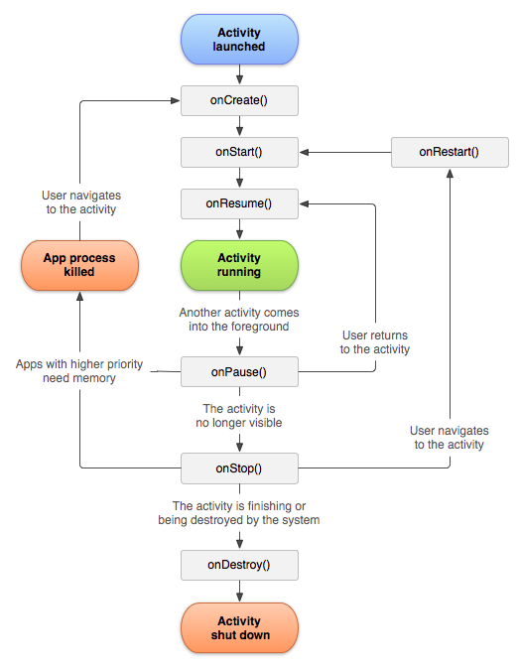

Fragments
Android fragment lifecycle is affected by activity lifecycle because fragments are included in activity.
The FragmentManager class is responsible to make interaction between fragment objects.

No. | Method | Description
1) | onAttach(Activity) | it is called only once when it is attached with activity.
2) | onCreate(Bundle) | It is used to initialize the fragment.(Don’t use this method to access view Hierarchy becoz activity onCreate() may or maynot be finished.Create background threads for long running operations)
3) | onCreateView(LayoutInflater, ViewGroup, Bundle) | creates and returns view hierarchy(fragment inflate garera return garney).(linking of layout to objects)
4) | onActivityCreated(Bundle) | It is invoked after the completion of onCreate() of the Activity method.(main kam yaha garney)
5) | onViewStateRestored(Bundle) | It provides information to the fragment that all the saved state of fragment view hierarchy has been restored.
6) | onStart() | makes the fragment visible.
7) | onResume() | makes the fragment interactive.
8) | onPause() | is called when fragment is no longer interactive.
9) | onStop() | is called when fragment is no longer visible.
10) | onDestroyView() | allows the fragment to clean up resources.
11) | onDestroy() | allows the fragment to do final clean up of fragment state.
12) | onDetach() | It is called immediately prior to the fragment no longer being associated with its activity.

InterFragment communication:
1.Make an Interface
2.implemented by Activity.
3.interface variable can hold the reference of subclass activity
(communicator=getActivity());==>in fragment1
4.communicator.respond()
5.Activity ko overridden method vitra fragment2 ko reference liney ra call the method of f2

